pw ■■

VK W I V I 3o

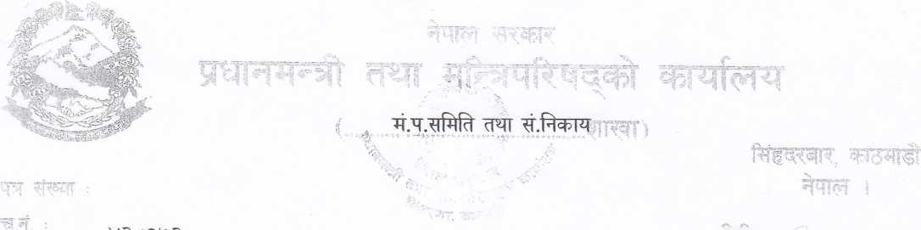

Ar fAm mwr i

W ?oi3^ i y 15o ttt ArAr AA dnr ww Adnrd AhAIA

fwr A wn AA ।

"A^ few <ui4M Aw A fwrAr Af wnwAr A

i <^-0^ ixi k Ar wm w.w.t.A. f^rfA wiki^ Ar AfeAAAT ^<5’4,4-11 ^T g^T 3{T^A W WM AAArT

^rft fWmtfAr At i " fwr ^stwr wwi^At ww fW ii^, ^o^^iisnc; t Ar ^<^1

'1’HAAA Si AT ^6\*4-11 ^TqTQT A^J?^ WST^tr SImAI oldcb'HI ^T

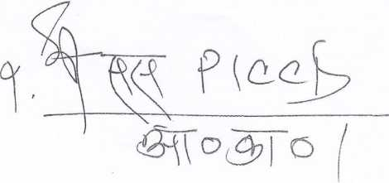wiww "A\*r fArw tMAT, ^oov1 Ar w 3^14^1\*1 A^t Art AT AAAt Awi And "dAr fAnr tMTA, ^oisv AUd Ai"

(wwd AA

AAt

